● Creation of New Dictionary

● Accessing Items in the Dictionary

● Change Values in the Dictionary

● Loop Through a Dictionary Values

● Check if Key Exists in the Dictionary

● Checking for Dictionary Length

● Adding Items in the Dictionary

● Removing Items in the Dictionary

● Remove an Item Using del Statement

● The dict() Constructor

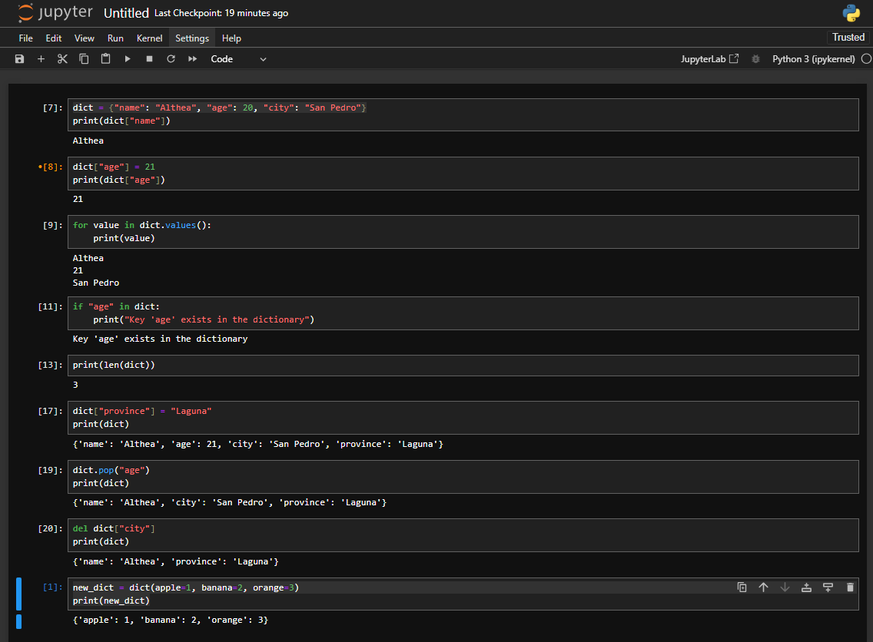

● Dictionary Methods

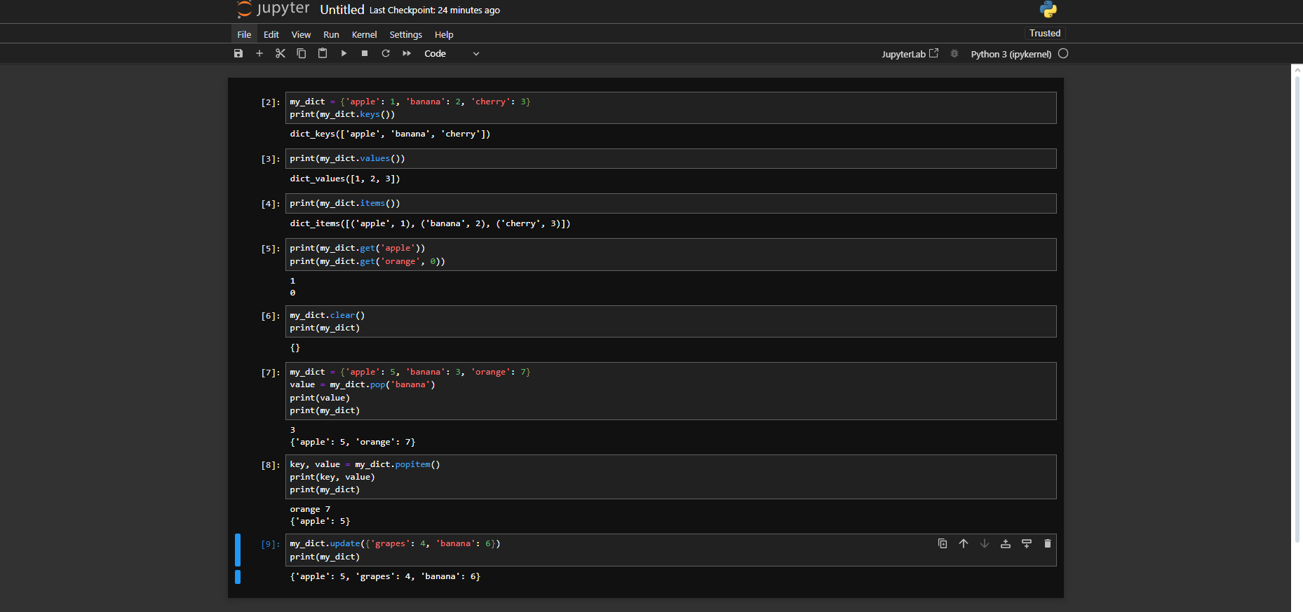

**Jupyter notebook**

● Adding Folder

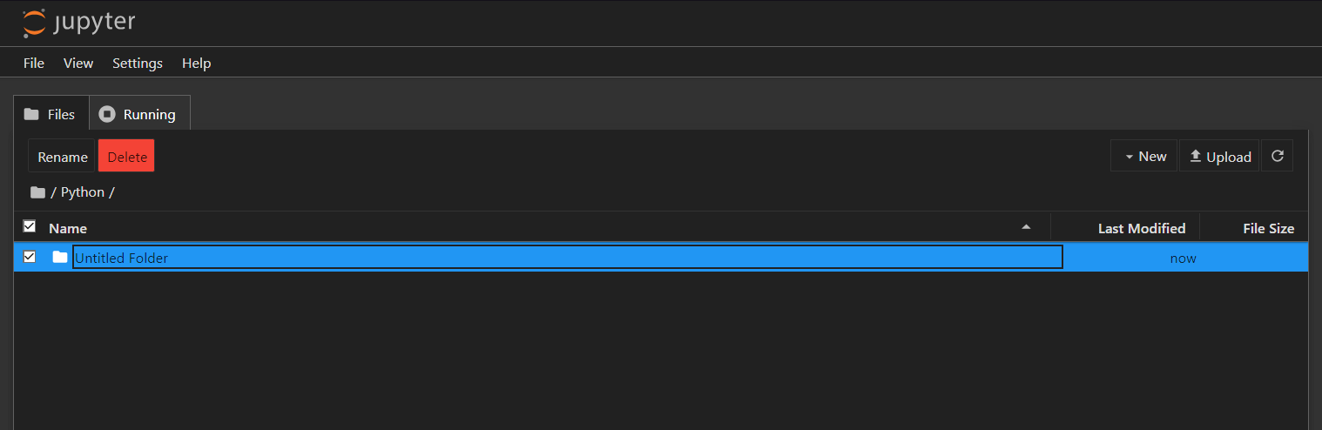

● Adding Text file

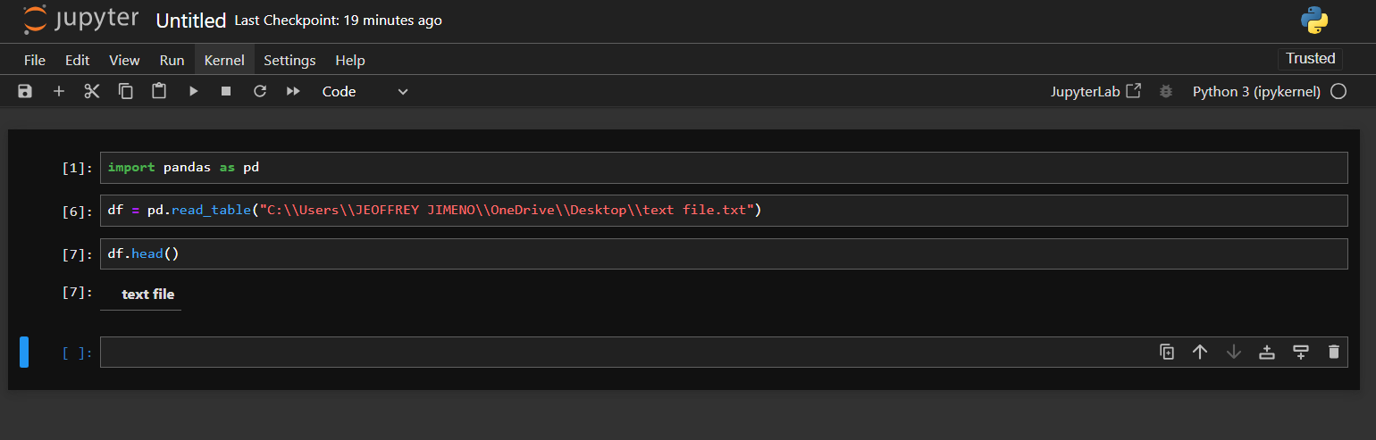

● CSV file for data analysis and visualization

